# CS 255 System Design

## Guilherme Pereira

## UML Diagrams

### UML Use Case Diagram

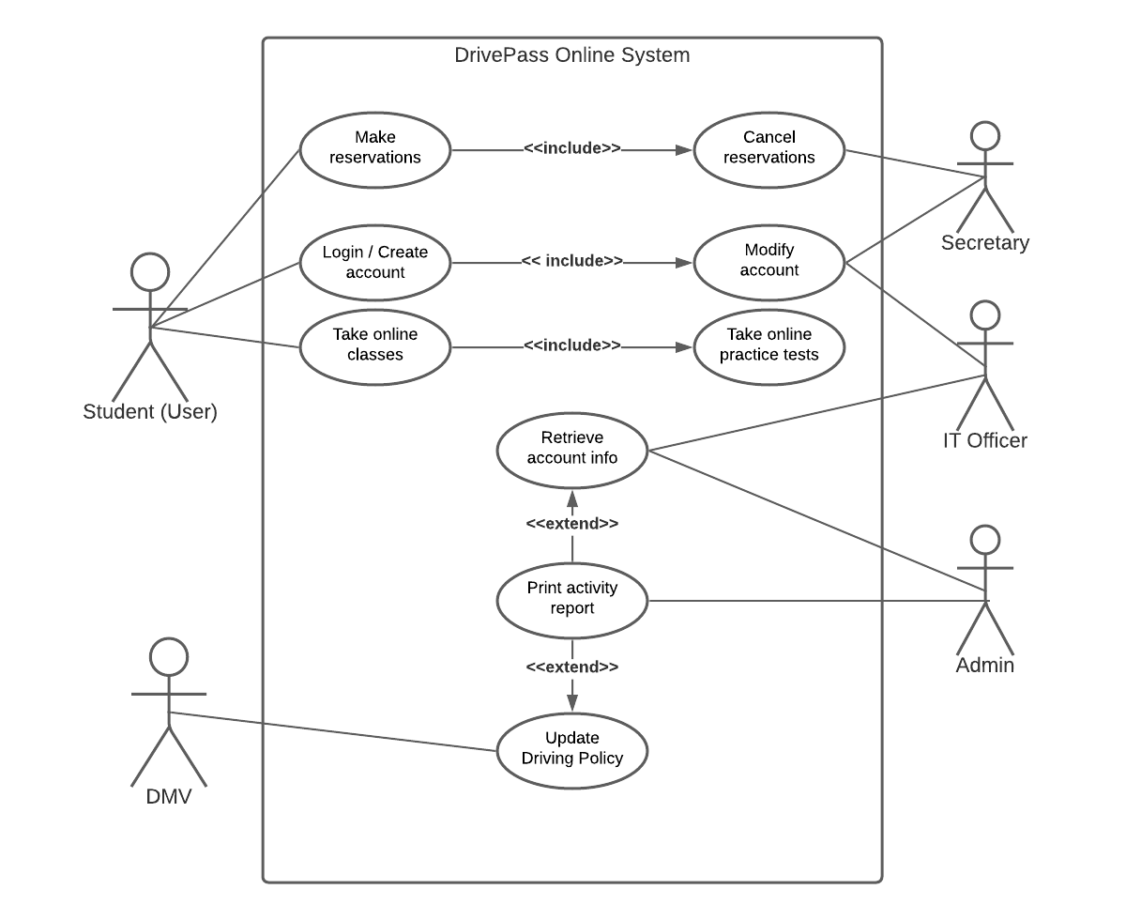

### UML Activity Diagrams

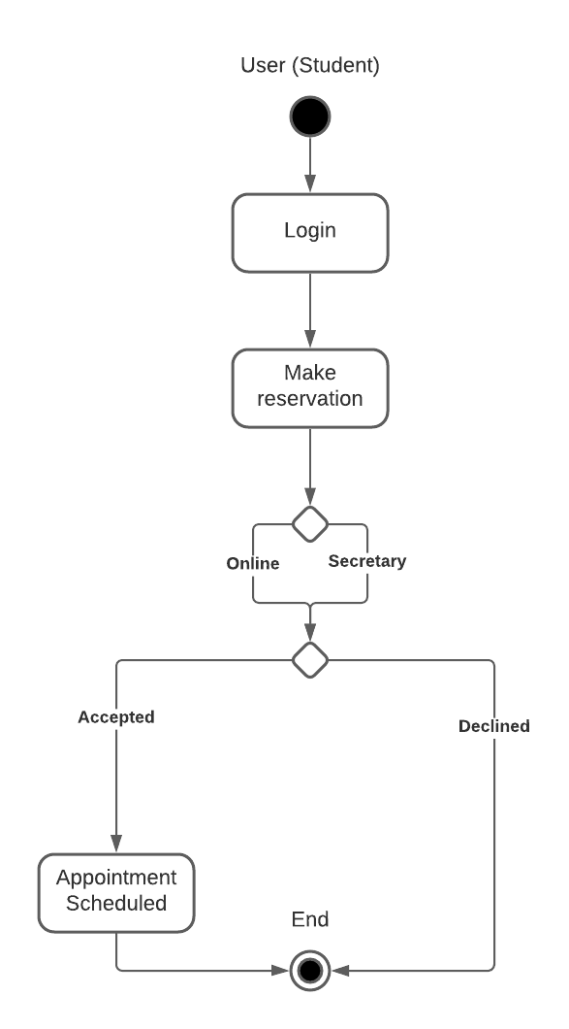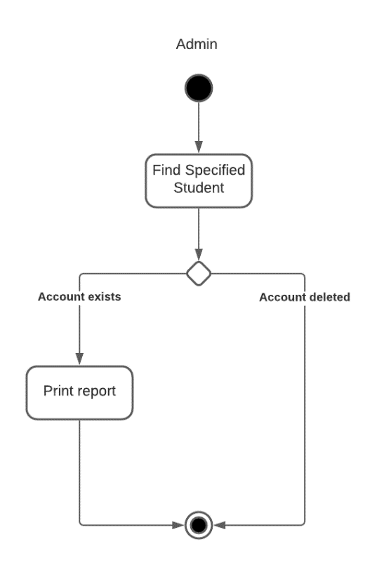

### UML Sequence Diagram

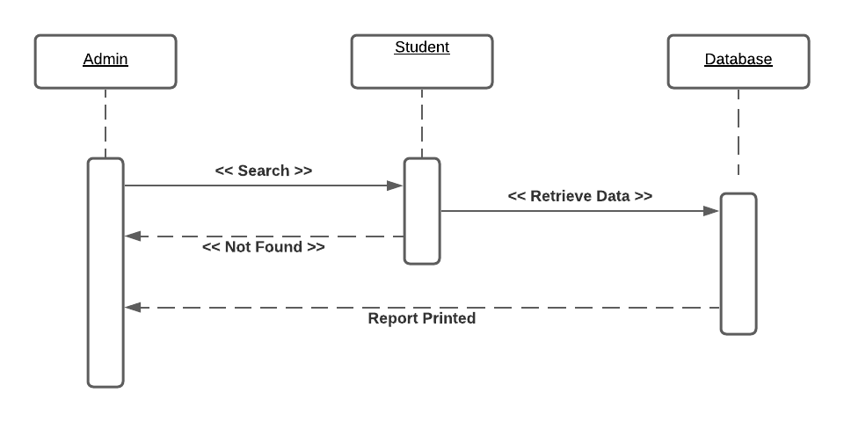

### UML Class Diagram

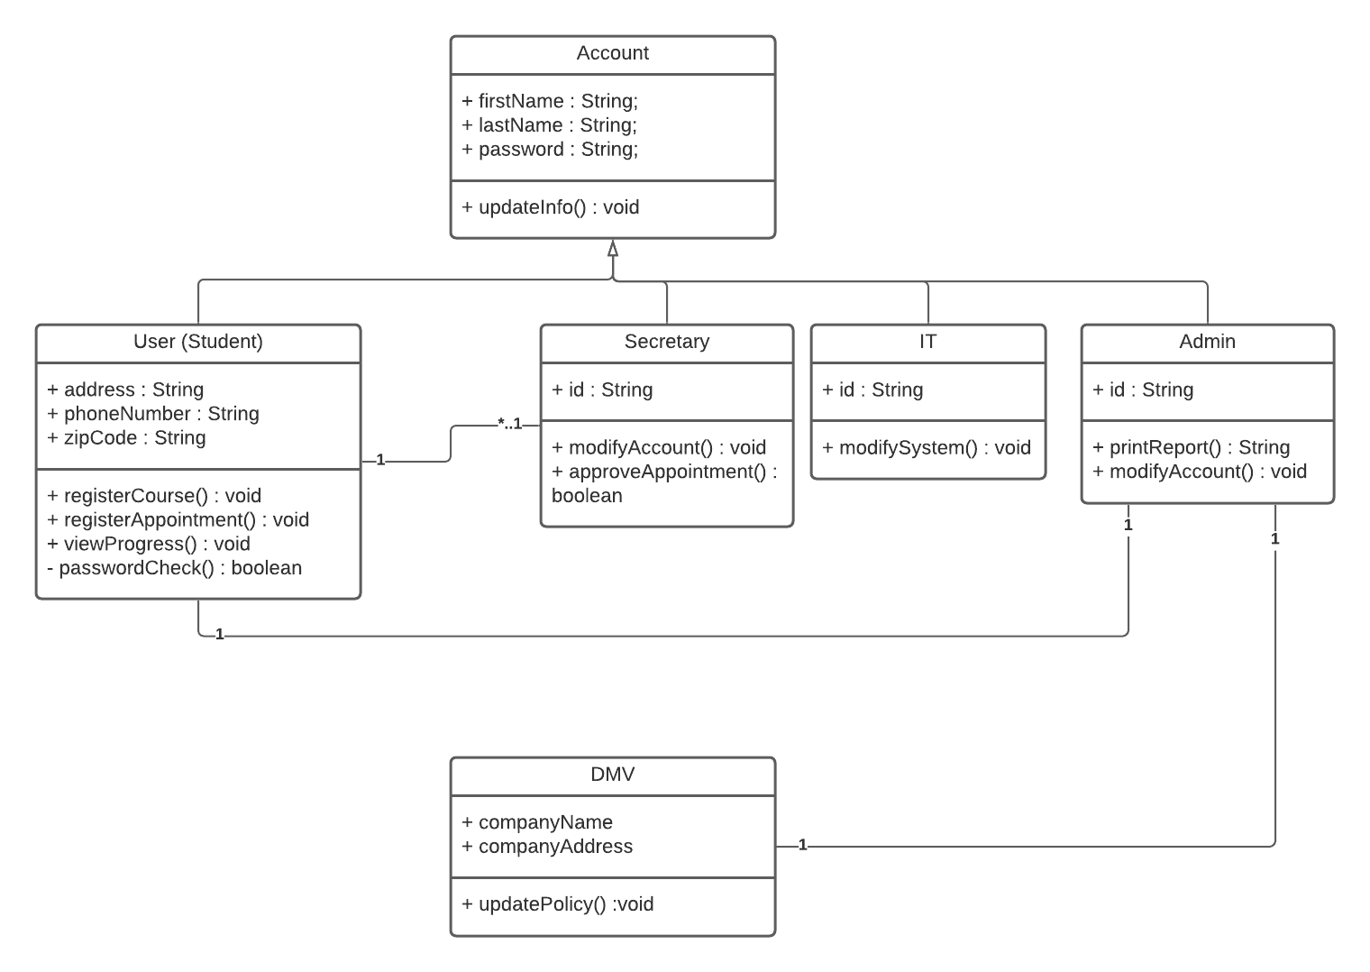

## Technical Requirements

Based off the diagrams shown above, the DriverPass system requires several tools, services, and components to function as intended. First, the system will be cloud-based and will need to have a web-browser for users to interact with. The operating platform should not be an issue as many well-known ones, such as Windows or Mac, support several kinds of web-browsers. The real question is what cloud service the system would like to use, as there are several such as Microsoft Azure and Amazon Web Service. Additionally, while the system is to be web-based at the start, there has been no mention whether it will be moved to being an application on smartphones.

The tools required for this system to work include all the actors to interact with the object, that being the user (student), secretary, IT officer, administration, and the DMV. Each actor has a special role to play to ensure the system runs as intended and meets the initial goals of DriverPass. The other more physical tools required for this system include the vehicles and their respective instructors to help give students on the road experience. Finally, the administrator will need to be able to print an activity report from a user to validate their current standing on a test or to verify someone’s integrity if they were to lose their account or something suspicious occurred.